SEATON ST PAUL’S CE JUNIOR SCHOOL
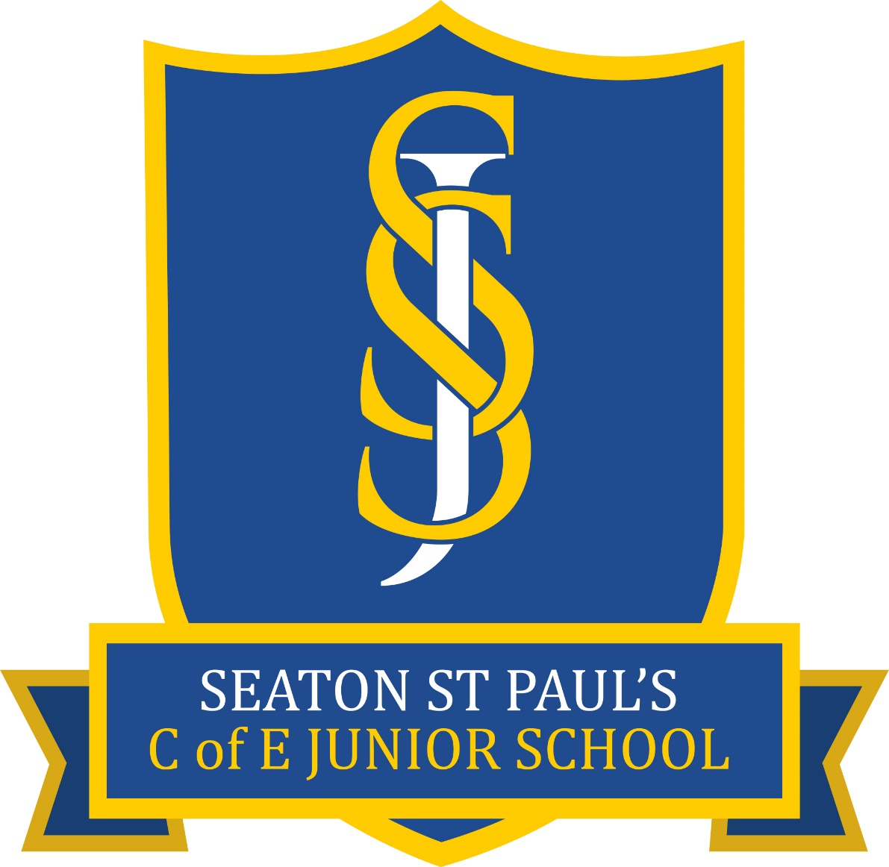
RELIGIOUS EDUCATION POLICY

Approved By: Curriculum, Inclusion and Community Committee

Ratified By: Full Governing Body

Reviewed: September 2024

Date of Next Review: September 2025

Reviewed by Religious Education Subject Governor
Signed: I. Grainger
Date: 10.09.24
Our vision for Religious Education (RE)
I have come that they may have life, and have it to the full. I am the good shepherd. The good shepherd lays down his life for the sheep. [John 10:10-11]
At Seaton St Pau’s CE Junior School, RE expresses and strengthens our vision, ethos and values that are at the heart of what we aim to do in every aspect of school life that offers human flourishing for all. The importance placed on the development of the whole child spiritually, morally, socially, culturally (SMSC) and intellectually is reflected in the RE curriculum. The aim of Religious Education at Seaton St Paul’s is to enable all children to develop an understanding of, and respect for, world religions, faiths and worldviews. This enables them to develop religious literacy – the ability to participate in balanced, well-informed and respectful conversations about religion and belief. As a Church of England school with a deeply Christian vision, our Religious Education curriculum enables our pupils to develop an in-depth, mature understanding of Christianity and its relevance to their own lives.
To achieve this, by the end of Year 6, our pupils will:
- Know about and understand Christianity as a living faith that influences the lives of people worldwide and as the religion that has most shaped British culture and heritage.
- Know and understand about other major world religions and worldviews, their impact on society, culture and the wider world, enabling pupils to express ideas and insights.
- Have developed their own spiritual/philosophical convictions, exploring and enriching their own beliefs and values.
In Seaton St Paul’s Church of England Junior School, where pupils and staff come from different faiths and none, RE is a highly valued academic subject that enables understanding of how religion and beliefs affect our lives. There is ‘a commitment to generous hospitality, being true to our underpinning faith, but with a deep respect for the integrity of other religious traditions (and worldviews) and for the religious freedom of each person’, Statement of Entitlement 2019.
Seaton St Paul’s provides a RE curriculum that is rich and varied and studies a range of world religions and worldviews. At the heart of RE in this school is the teaching of Christianity, rooted in the person and work of Jesus Christ that enables learners to acquire a thorough knowledge and understanding of the Christian faith.
Our aim is to provide a wide range of opportunities for learners to understand and to make links between the beliefs, practices and value systems of the range of faiths studied. We aim to provide suitable learning opportunities that match the needs of all children. This includes providing relevant support, adapted activities and using a range of teaching and learning styles within lessons.
Pupils are encouraged to know about, understand and respond to the ultimate questions of life and ethical issues. Our curriculum inspires pupils to explore, develop and affirm their own faith/worldviews and values whilst having respect for the faith, beliefs and values of others. We are committed to education for wisdom, hope, community and dignity.
Encountering religion and belief includes:
- Enquiry into and investigation of the nature of religion;
- Key beliefs and teachings, practices;
- Impact on the lives of believers and communities;
- Different ways of expressing beliefs, teachings and practices;
- Developing pupil skills of interpretation, analysis and explanation in relation to religion;
- Pupils’ communication of their knowledge and understanding using specialist vocabulary;
- Pupils reflection on and response to their own experiences, questions of identity and belonging, meaning purpose and truth, values and commitment; and
- Development of religious literacy.
Aims

In keeping with the expectations set out in the Statement of Entitlement, the aims of RE in this school are:

- To enable pupils to know about and understand Christianity as a diverse global living faith through the exploration of core beliefs, using an approach that critically engages with biblical text.
- To enable pupils to gain knowledge and understanding of a range of religions and worldviews appreciating diversity, continuity and change within the religions and worldviews being studied.
- To facilitate pupils’ engagement with challenging questions of meaning and purpose raised by human existence and experience.
- To enable pupils to recognise the concept of religion and its continuing influence on Britain’s cultural heritage and in the lives of individuals and societies in different times, cultures and places.
- To encourage pupils to explore their own religious, spiritual and philosophical ways through living, believing and thinking.

Legal Framework

As a voluntary controlled school, as required by law, we provide RE which meets the requirements of the Cumbria Locally Agreed Syllabus 2023 (the LAS).

Parents have a legal right in accordance with the Education act 1996 to withdraw their children from RE lessons. As this subject is central to the life and identity of Seaton St Paul’s Church of England Junior School, we ask parents to discuss with the head teacher any reasons they might have for doing this. We aim to provide a quality RE curriculum that can be sensitively and appropriately taught to all pupils, by all staff. We ask that requests for full or partial withdrawal from RE should be made in writing to the headteacher.
Curriculum for Religious Education

RE is an academic subject that has a high profile in our school curriculum. It is given priority by leaders, including governors, who ensure that the teaching, learning and resourcing of RE is comparable with other curriculum subjects.

This means that the RE curriculum:

- is intrinsic to the outworking of our distinctive Christian vision in enabling all pupils to flourish;
- contributes to British values and to pupils’ spiritual, moral, social and cultural development;
- is delivered in an objective, critical and pluralistic manner to engage and challenge all pupils through an exploration of core concepts and questions;
- provides meaningful and informed dialogue with a range of religions of worldviews;
- reflects a good balance between the disciplines of theology, human science and philosophy;
- enables pupils to acquire a rich, deep knowledge and understanding of Christian belief and practice, including the ways in which it is diverse;
- provides opportunities for pupils to understand the role of foundational texts, beliefs, rituals and practices and how they help to form identity in a range of religions and worldviews;
- ensures that all pupils’ contributions are valued in RE as they draw on their own experiences and beliefs;
- is adapted to ensure all pupils make progress and flourish.

In addition to providing RE which meets the requirements of the Locally Agreed Syllabus (LAS), we use the Questful RE scheme of work. We adopted the Quesful scheme to ensure that our pupils, the vast majority of whom join our school from a non-faith infant setting, are provided with a deeper understanding of Christianity. In addition, opportunities to experience major world faiths and non-religious world views in order to impart knowledge and understanding that will equip our pupils to encounter and embrace life’s experiences in our world today and in the future. We also use Understanding Christianity to support the teaching of RE.

There are clear learning outcomes for all units of work, based on the appropriately high expectations we have for all our pupils. Our RE curriculum is sequential and builds on prior learning which ensures that there is continuity and progression for all pupils as they move through the school.

Curriculum balance and time
At Seaton St Paul’s CE Junior School, Religious Education enables every child to flourish and to ‘live life in all its fullness’. (John 10:10).
At Seaton St Paul’s, the faiths and worldviews taught in RE are: Christianity, Judaism, Hinduism, Buddhism, Islam, Sikhism and Humanism.
RE has a of curriculum time 45 hours per year (1 hour a week). In addition to this, we have RE enrichment opportunities which include visits to places of worship alongside visits from people of different faiths.

Of the RE taught at Seaton St Paul’s, 60% focusses on Christianity and 40% focusses on other faiths. For our unique context, we feel this split works well for our children. It provides them with the opportunity to learn about a wide variety of world faiths alongside ensuring we can provide a solid understanding of Christianity from their starting point with us in Year 3. Allocated curriculum time is only ever spent on RE related learning with Collective worship being timetabled separately.

Spiritual, Moral, Social and Cultural Development (SMSC) / British Values

- RE is a key opportunity to develop morally, spiritually, socially and culturally. We invite pupils to reflect on their personal responses to issues and consider respectfully those of others.
- We encourage pupils to consider the answers offered by faith and other groups to questions of meaning and purpose and to problems within societies as well as their own experiences.
- RE also strongly supports the school’s citizenship work by introducing pupils to the significance of belonging to a community, diversity within communities, faith rules and their application to moral and ethical issues and cultural influences on religious practice. This includes work on the British Values of democracy, the rule of law, individual liberty, and respect.

Health and Safety

Health and safety issues may arise in RE on a number of occasions for example, when pupils:

- Handle artefacts
- Consume food
- Visit places of places.

Teachers will conform to guidelines in the school’s health and safety policy in these circumstances.

Recording, Feedback, Assessment and Monitoring

At Seaton St Paul’s, we use the Questful RE ladder of expectation and achievement to plan excellent tasks at the right level appropriate for the pupils’ experience, knowledge and ability. If the right tasks are set then the outcomes will be achieved. Teachers set appropriate tasks and make judgements as to whether or not pupils in their class are meeting or not meeting expectations of achievement. As per whole curriculum policy, at the end of an individual piece of work, teachers will indicate whether the objective has been achieved using the following structure:

-Green dot next to title/objective – the child has met the lesson’s objective
-Orange dot next to title/objective – the child has not met the lesson’s objective

At the end of each unit of study, teachers, using the Questful RE maps and ladders of achievement, create an assessment activity to make judgements as to whether or not pupils are meeting expectations of achievement. In addition, these assessment tools can be used as a pre-learning task as and when required. Further evidence and details of this can be obtained from the RE subject leader, Mrs Katharine Hughes.

At Seaton St Paul’s, each child will have their own RE book and each class will have a class RE ‘floor book’. Children’s individual books move up year groups with the child, a title page each September indicates the beginning of a new academic year. The two books work together to provide the evidence that can be assessed and monitored. The class ‘floor book’ will contain evidence such as pupils’ discussions, comments and ideas, records of visits and visitors, photographs, group work, post it notes and printed work from the interactive whiteboard. At the end of each unit of work, each child completes an individual assessment, created by teachers, using questions from the Questful RE maps alongside teacher created questions to ensure a good understanding of core knowledge and a progressive understanding. RE is marked in-line with the school policy so there is consistency across all subjects in the school. Our pedagogical approach uses in-lesson feedback and effective and inclusive questioning and reflection opportunities which regularly checks for understanding. The RE Co-ordinator (Mrs Katharine Hughes) carries out a range of monitoring activities including: RE book look/work scrutiny, pupil voice and staff questionnaires across the school regularly. The Local Governing Body, specifically the RE link Governor (Rev Ian Grainger) are involved in monitoring the RE provision.

Leadership & Management
The teaching, assessment and resourcing of RE is managed by the RE subject leader (in collaboration with leaders) to ensure that statutory requirements and those set in the Statement of Entitlement are met.
The RE subject leader will:
- will support and regularly monitor the subject across the school for its strengths and areas for development in line with SIAMS and Ofsted guidance about self-evaluation;
- undertake relevant and regular CPD to keep their subject knowledge and expertise up to date, and to ensure that staff receive appropriate training for the teaching and assessment of RE;
- report regularly to the governing body so that everyone has an overview about progress and outcomes in RE; and
- ensure that RE provision reflects diocesan advice and recommendations.
Review

There will be a review of this policy every year. Its impact will be monitored by Mrs Katharine Hughes (Subject Lead), Rev Ian Grainger (Link Governor) and Mrs Lynn Carini (Headteacher). This will include discussions with pupils, other members of staff, observing teaching and scrutinising pupils’ work.

Date of policy: September 2024
Review date: September 2025
Signed: K S Hughes

